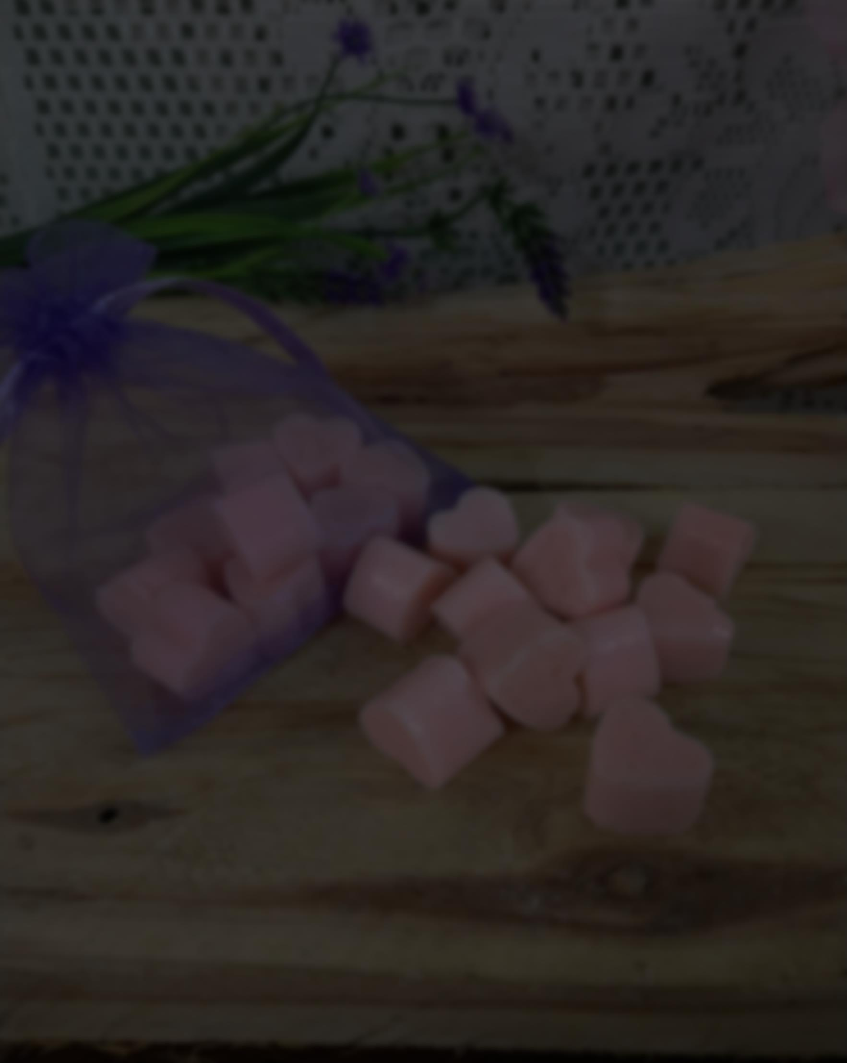
Happy New Year! I was really hoping that this year would come in and be really quiet and let us all take a huge deep breath in and finally relax our shoulders. But alas, that is not reality. My hope for all of us, is peace and quiet. To get slowly back to some sort of ‘normal’ but mostly fun! We have lost our fun and we need it back.

I must admit I have been struggling with what to share in this time of our world. Most everyone has heard everything they possibly want to hear and not want to hear. I have found that prayer/meditation has been a strong go-to for me. Finding some form of quiet in all the noise, where you can find a little bit of happiness and maybe put a skip in your step.

Another go-to has been diffusing Essential Oils and wearing my diffuser necklace most days. I’ve been leaning toward the citrus oils quite a bit. Citrus Oils are what I call, happy oils. Lemon and orange bring thoughts of sunshine. When I think of lime, I see green trees and the abundance of life. Grapefruit for that small like sour kick to give that skip an extra bounce!

Then we have Valor – my most favorite oil of all time! Valor is blend of spruce, rosewood, blue tansy (what gives valor its blue tone!) and frankincense. This blend promotes feelings of courage, confidence and self-esteem – a perfect blend in this uncertain time. I put a few drops on my diffuser necklace and wear it when I just need a little bit of focus and confidence. I use it on my wrists and my 3rd eye Chakra before I start a workout session. It is the kick that helps you get out of your head and go for what is your aim – be it, a heavier weight set, a promotion or helping your kids do math.

If you have a goal you would like to achieve and want to share, I’d be interested in knowing. I’ll have a raffle in at the end of January for someone to win a sample of Valor!

As we start our travel into the New Year, my wish is that you each find that skip and that happy dance that can keep you moving forward in the most positive way possible. Some of us are struggling more than others and when we lift each other up and support each other, it helps both the lifter and the liftee. Embrace each other through all our differences; it is what makes this Country as great as it is. Let’s be the happy positive voice that everyone needs. And if you need a hand or a shoulder, ask for help or guidance because we all need a lift at any given time.
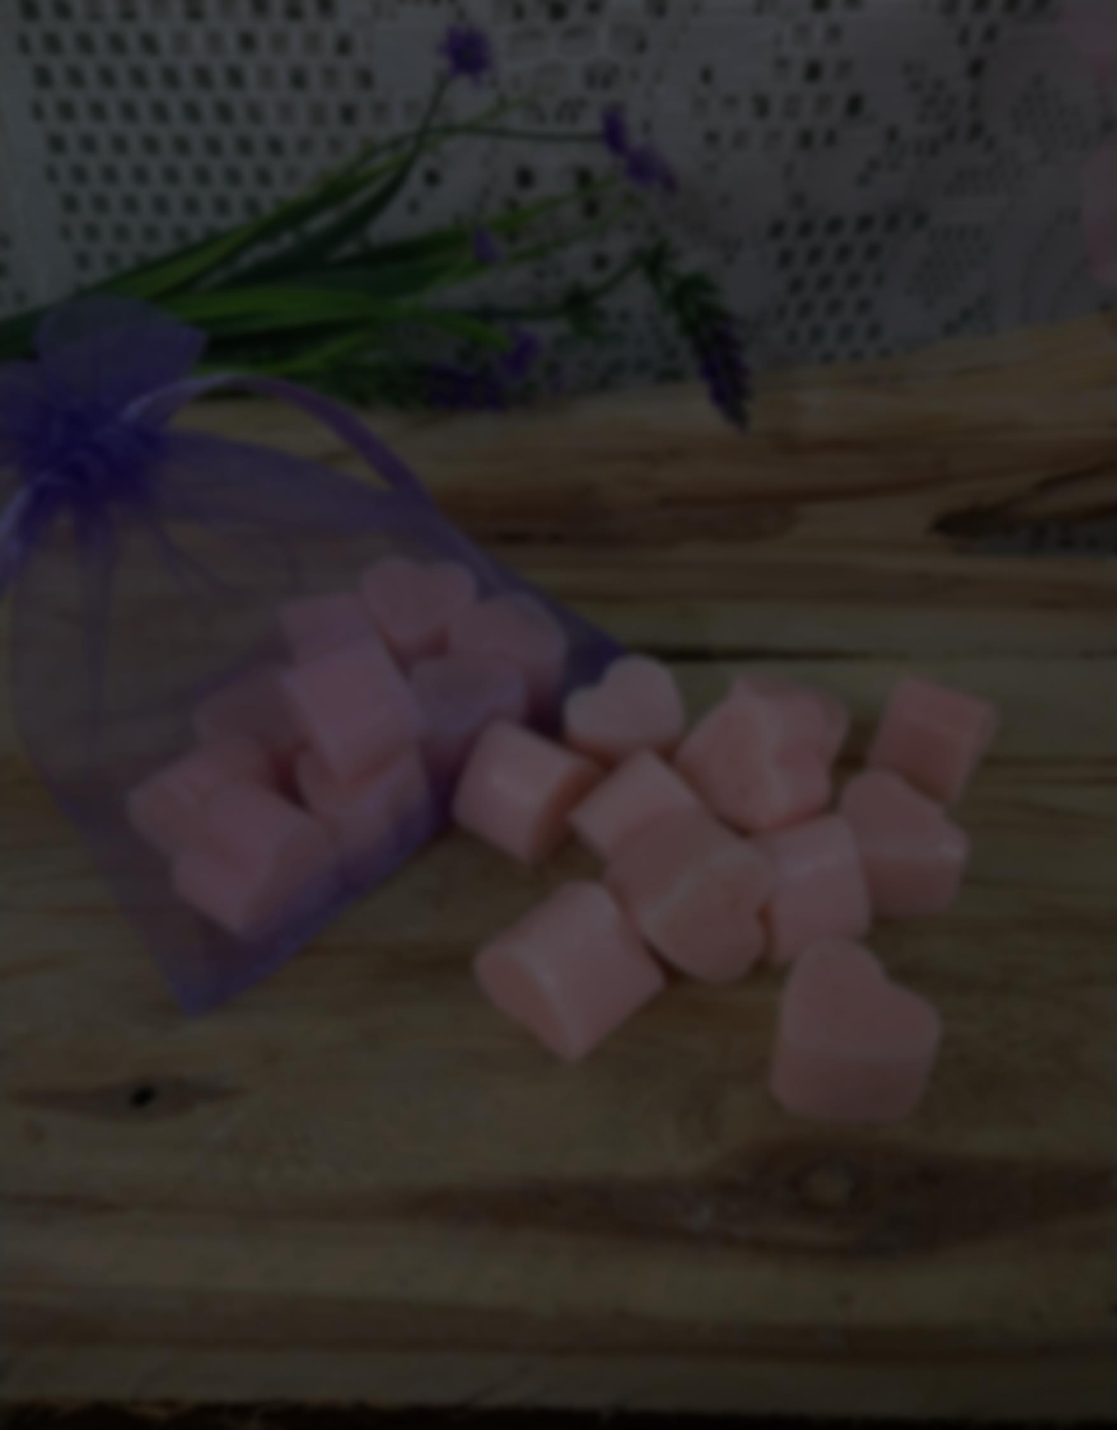
There are quite a few items in my Etsy store that can lend a hand, Aromatherapy wise. From rollerballs to shower melts. Different soaps for lifting up the spirit to soaps that can lend more to a more grounding feeling. There are some Valentine gifts and ideas available also. Fun is my word for the month! Here are some samples from my store – come visit and look around!

This roller is just like it says – makes you want to smile, dance, feel a little romance and generally feel fantastic. Very floral and feminine is oils with Jasmine, Rose, Geranium, Ylang Ylang and those happy citrus oils, Tangerine and Bergamot. Use as a perfume or just because!
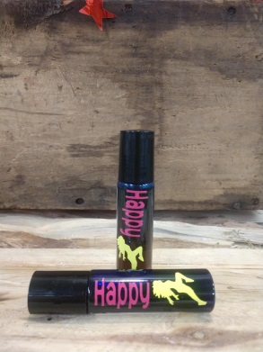 | 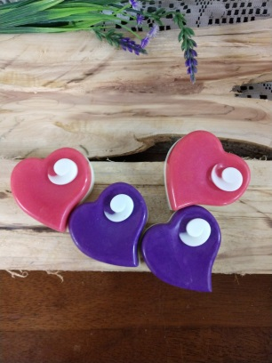  Sweet soaps for your special Valentine. Beautifully made to bring love and romance to the front! Essential Oils of Grapefruit, Ylang Ylang and Cardamon - a lovely feminine sultry scent.
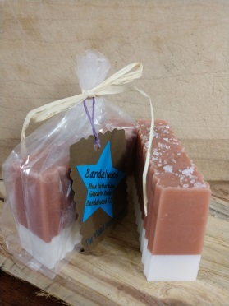  Just as have uplifting soaps, we have the grounding soaps to help settle and calm. This is a wonderfully scented soap using Sandalwood EO that both the ladies and the men love! Great for anxiety and to help bring clarity. | 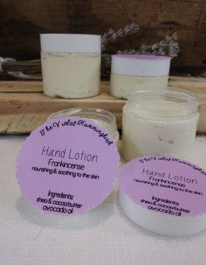  To help hands, feet and other dry spots, we have all natural nontoxic hand cream. It has a nice way of going on and doesn’t leave your hands feeling greasy. Great addition to your winter skin routine! Made with Frankincense EO for that added benefit of healing.

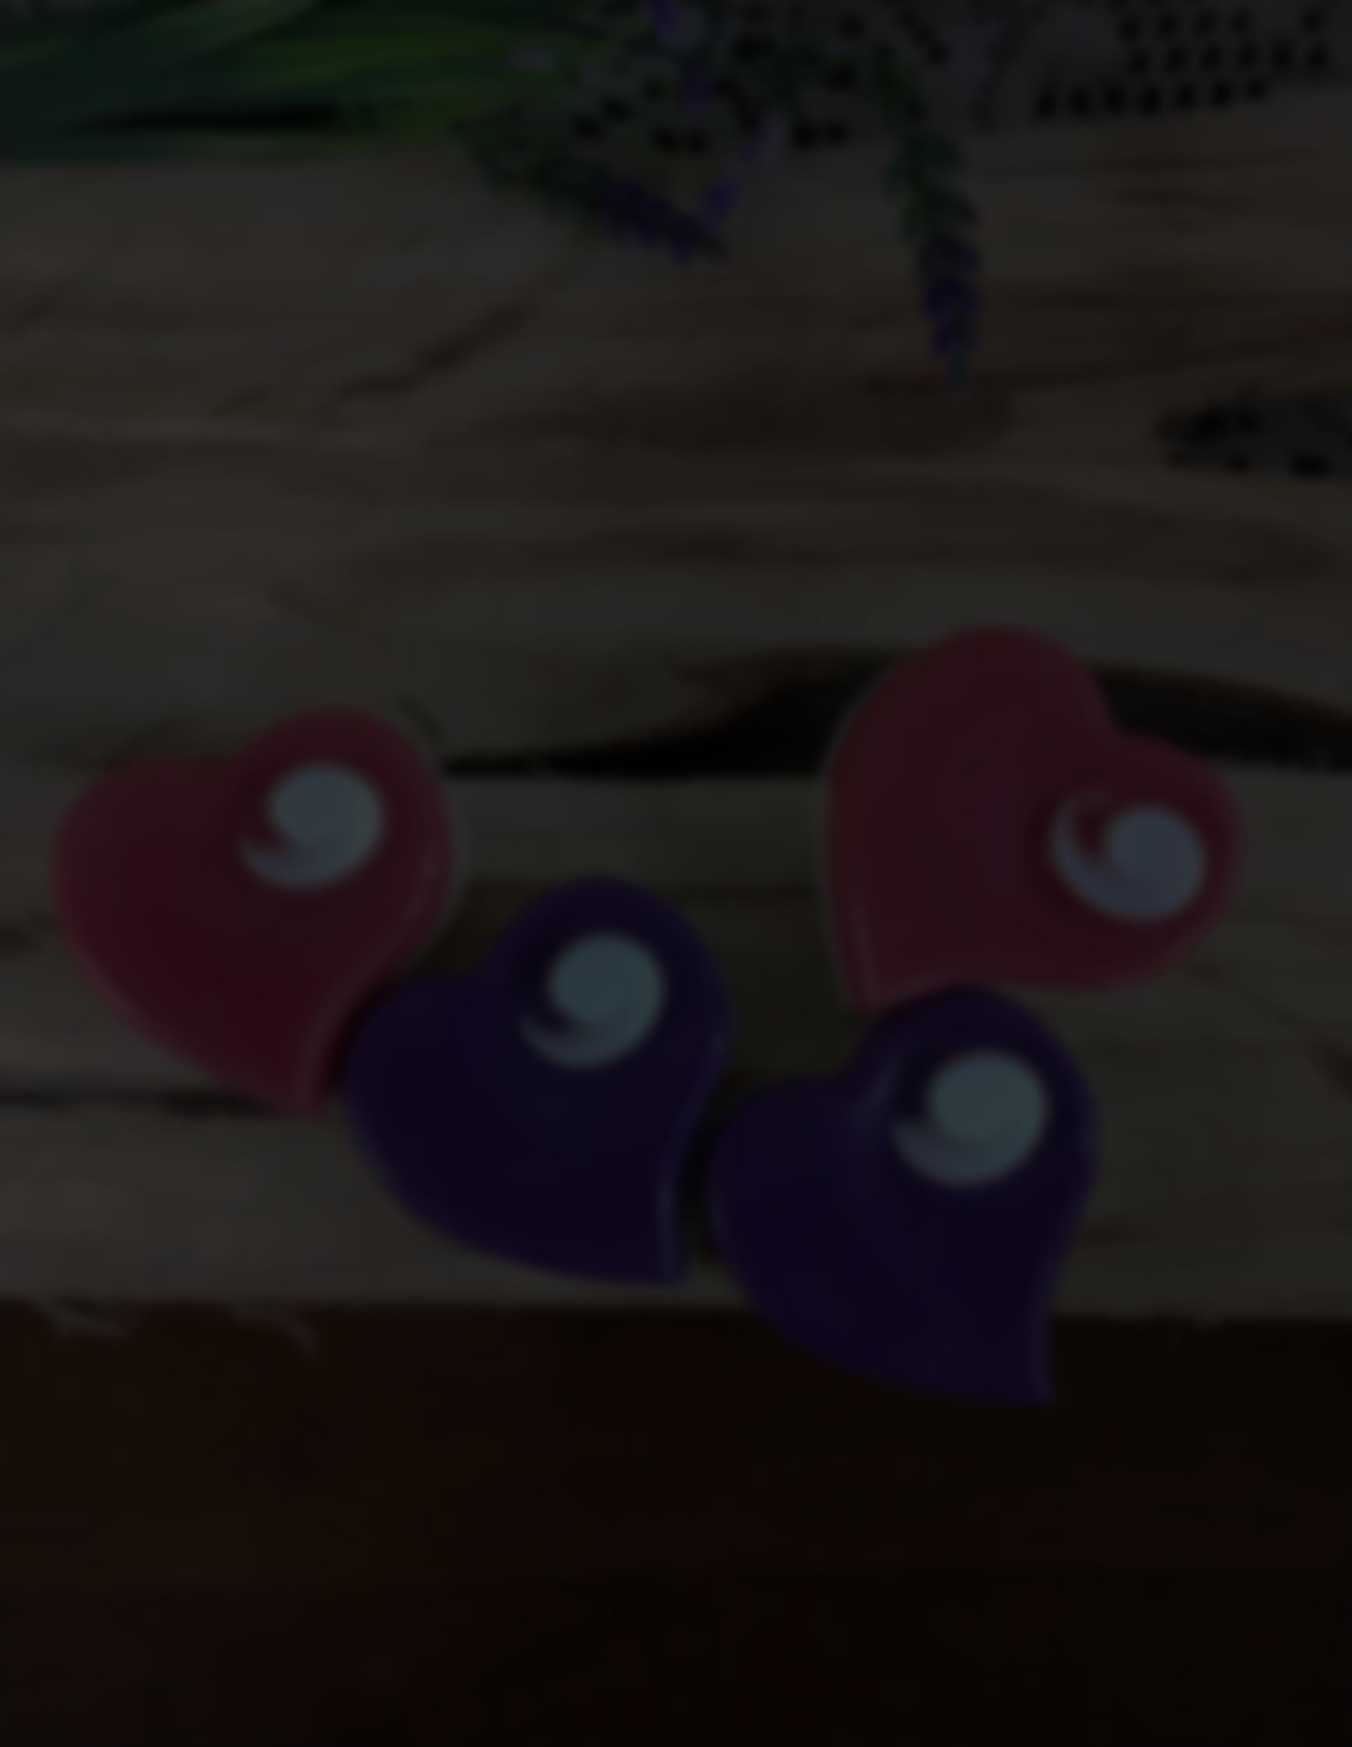
Final Thoughts:

Thank you for taking the time to read this Newsletter. Send in your goals to be added to the Valor Give away! I look forward to seeing all the great ideas you all have!

If you have any questions or have a question I can research an answer, please reach out to me. I love sharing new ideas and thoughts with all of you! The more we all know, the better we will all be. I welcome all comments and suggestions. Till next month!

If you are in need of a refill of an Essential Oil or rollerball/cream or interested in learning more about the Essential Oils, please email me directly. If you need a refill head to my Etsy page or my website or contact me via email for any special orders.

Peace, Love and Joy to all!
/Penny

You can reach me at:
www.theviolethummingbird.com
Theviolethummingbird@gmail.com
https://www.etsy.com/shop/TheVioletHummingbird

** Disclaimer – Always know where your oils are sourced from. I use Young Living Essential oils because they own all their farms, have a strong Seed to Seal promise and how they maintain their farms. Know your source and always be extra vigilant.

Disclaimer: I am not a doctor, nor do I try to be one. I cannot diagnose, cure or prevent any disease. I share my knowledge freely but it is not a substitute if you have a medical condition that persists. Please contact your physician if you do.

